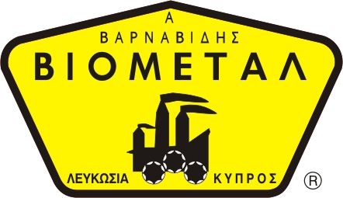
NICOSIA HEAD OFFICE
P.O.Box 21212, 1504 Nicosia. Cyprus
Tel: +357-22354744, Fax: +357-22354932
LIMASSOL OFFICE
Tel: +357-25589913, Fax: +357-25586407
e-mail: viometal@logosnet.cy.net
web: www.viometal.net
VIOMETAL LTD
A. V a r n a v i d e s
Manufacturing & Engineering
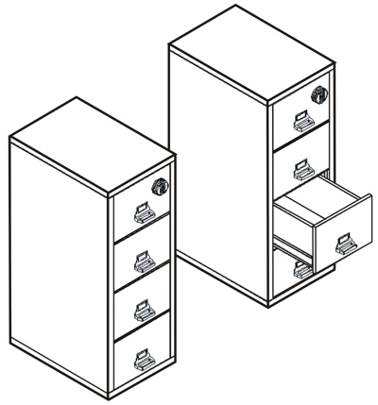

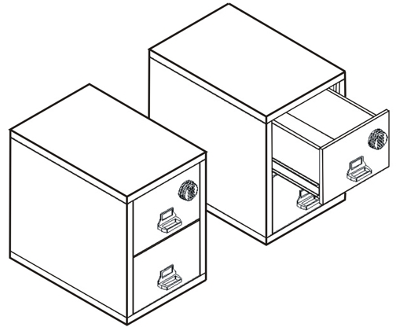
FIREKING FIRE PROOF FILING CABINETS
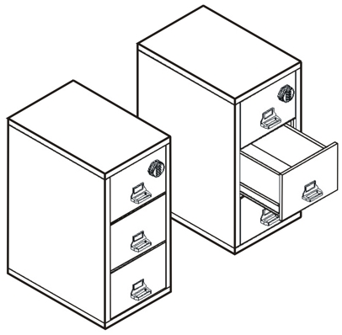

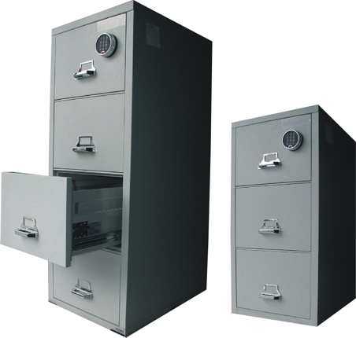

- 100% Gypsum. Reinforced body
- S&G Electronic Lock
- Environmentally Friendly Powder Coating Paint
CODE | WIDTH IN mm | DEPTH IN mm | HEIGHT IN mm | DESCRIPTION | PRICE
FFC2/E | 540 | 800 | 760 | Fireking Fireproof Cabinets – 2 Drawers | €1,565.00+VAT (€1,831.05)
FFC3/E | 540 | 800 | 1100 | Fireking Fireproof Cabinets – 3 Drawers | €1,785.00+VAT (€2,088.45)
FFC4/E | 540 | 800 | 1450 | Fireking Fireproof Cabinets – 4 Drawers | €1,930.00+VAT (€2,258.10)

SAFES 10-12
Ref: V007
    - Prices do not include any additional costs for forklift lifting expenses.

OFFICE FURNITURE, MOBILE SYSTEMS, STORAGE SYSTEMS, SHELVING SYSTEMS, SAFES & VAULTS

