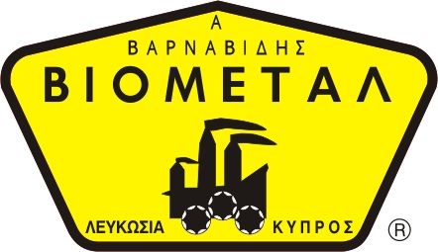
NICOSIA HEAD OFFICE
P.O.Box 21212, 1504 Nicosia. Cyprus
Tel: +357-22354744, Fax: +357-22354932
LIMASSOL OFFICE
Tel: +357-25589913, Fax: +357-25586407
e-mail: viometal@logosnet.cy.net
web: www.viometal.net
VIOMETAL LTD
A. V a r n a v i d e s
Manufacturing & Engineering

DOCU-S/KC HEAVY DUTY FIREPROOF MEDIA SAFE
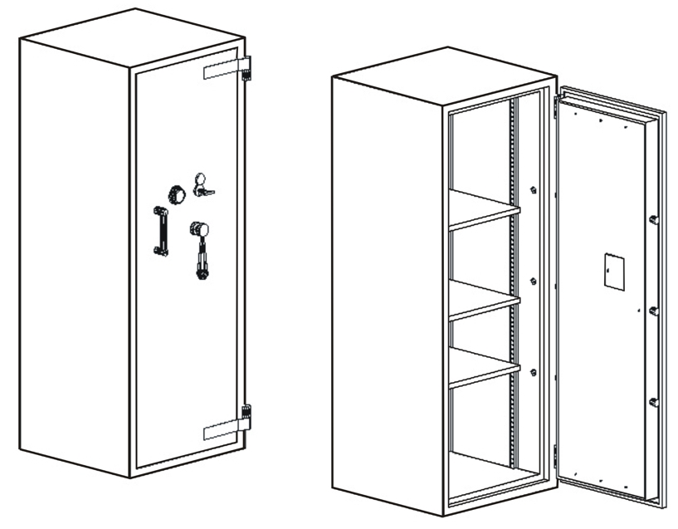

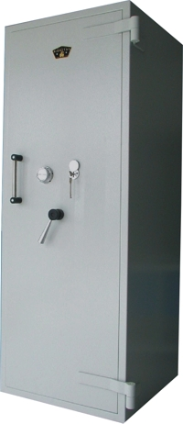
DESCRIPTION
Code: DOCU-S/KC
HEAVY DUTY FIREPROOF MEDIA SAFE
With (3+1) height adjustable shelves
External Dimensions: 68W x 70D x 180H
Internal Dimensions: 55W x 50D x 168H
Useful Volume: 462 Litres
Weight: 500kg
Price: €1,930.00+VAT (=€2,258.10)

- Supplied by default with one key lock and one mechanical combination.
- Optional: Digital lock instead of mechanical €100.00+VAT (=€117.00).
  - Extra additional digital lock €280.00+VAT (=€327.60)

    - Prices do not include any additional costs for forklift lifting expenses.
SAFES 09

Ref. V006

OFFICE FURNITURE, MOBILE SYSTEMS, STORAGE SYSTEMS, SHELVING SYSTEMS, SAFES & VAULTS

