
NICOSIA HEAD OFFICE
P.O.Box 21212, 1504 Nicosia. Cyprus
Tel: +357-22354744, Fax: +357-22354932
LIMASSOL OFFICE
Tel: +357-25589913, Fax: +357-25586407
e-mail: viometal@logosnet.cy.net
web: www.viometal.net
VIOMETAL LTD
A. V a r n a v i d e s
Manufacturing & Engineering

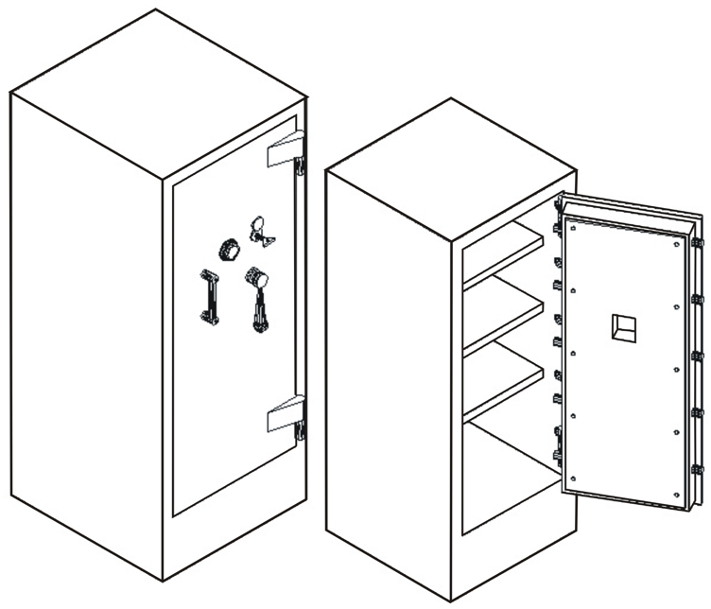
VB2/KC

VB1/KC

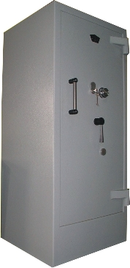

 | VB1/KC | VB2/KC
External Dim.: | 61W x (60+6)D x 151H | 74W x (70+6)D x 170H
Internal Dim.: | 45W x 38D x 117H | 58W x 50D x 134H
Useful Volume: | 200Litres | 385 Litres
Weight: | 800kg | 1200kg
Price: | €2,700.00+VAT (=€3,159.00) | €4,500.00+VAT (=€5,265.00)

- Supplied by default with one key lock and one mechanical combination.
- Optional: Digital lock instead of mechanical €100.00+VAT (=€117.00).
  - Extra additional digital lock €280.00+VAT (=€327.60)

    - Prices do not include any additional costs for forklift lifting expenses.
SAFES 07,08
Ref: V005

OFFICE FURNITURE, MOBILE SYSTEMS, STORAGE SYSTEMS, SHELVING SYSTEMS, SAFES & VAULTS

