
NICOSIA HEAD OFFICE
P.O.Box 21212, 1504 Nicosia. Cyprus
Tel: +357-22354744, Fax: +357-22354932
LIMASSOL OFFICE
Tel: +357-25589913, Fax: +357-25586407
e-mail: viometal@logosnet.cy.net
web: www.viometal.net
VIOMETAL LTD
A. V a r n a v i d e s
Manufacturing & Engineering

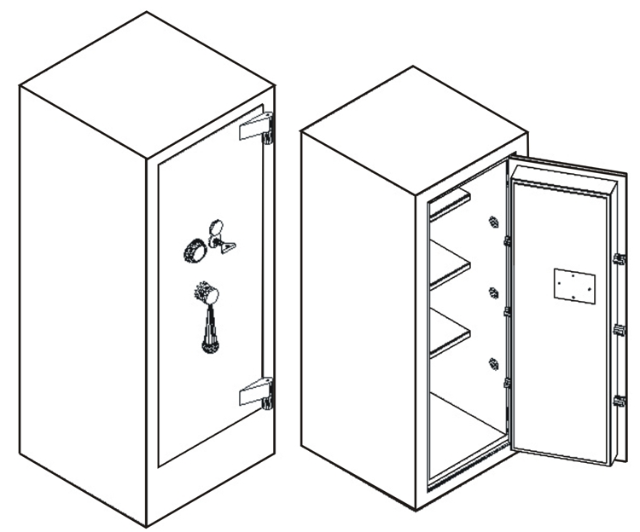
VA2/KC

VA1/KC

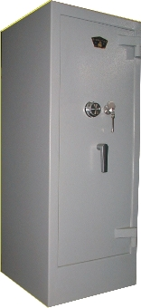

 | VA1/KC | VA2/KC
External Dim.: | 50W x (50+6)D x 120H | 56W x (56+6)D x 142H
Internal Dim.: | 35W x 32D x 105H | 41W x 38D x 113H
Useful Volume: | 115Litres | 175 Litres
Weight: | 400kg | 590kg
Price: | €1,950.00+VAT (=€2,281.50) | €2,150.00+VAT (=€2,515.50)

- Supplied by default with one key lock and one mechanical combination.
- Optional: Digital lock instead of mechanical €100.00+VAT (=€117.00).
  - Extra additional digital lock €280.00+VAT (=€327.60)

    - Prices do not include any additional costs for forklift lifting expenses.
SAFES 05,06
Ref: V004

OFFICE FURNITURE, MOBILE SYSTEMS, STORAGE SYSTEMS, SHELVING SYSTEMS, SAFES & VAULTS

