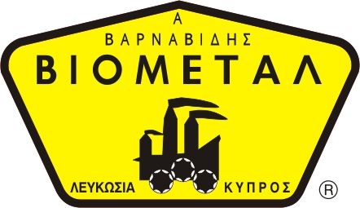
SAFES 04
NICOSIA HEAD OFFICE
P.O.Box 21212, 1504 Nicosia. Cyprus
Tel: +357-22354744, Fax: +357-22354932
LIMASSOL OFFICE
Tel: +357-25589913, Fax: +357-25586407
e-mail: viometal@logosnet.cy.net
web: www.viometal.net
VIOMETAL LTD
A. V a r n a v i d e s
Manufacturing & Engineering

VHS 90/KC
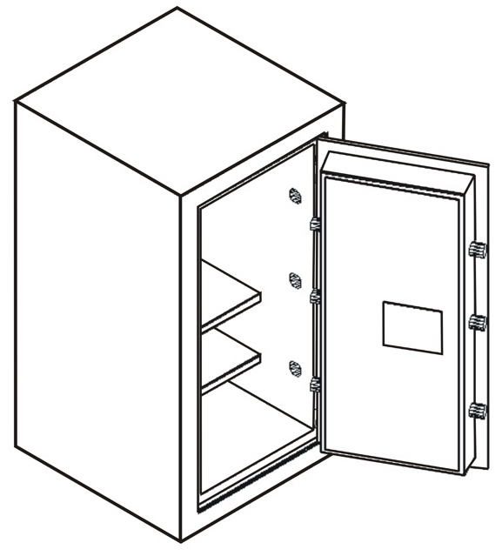

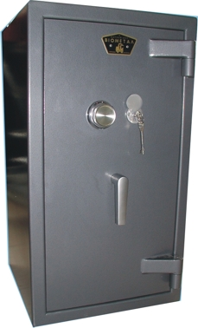

DESCRIPTION
Code: VHS90/KC
SAFE FOR OFFICE / HOME USE
External Dimensions: 50W x (50+6)D x 90H
Internal Dimensions: 37W x 32D x 77H
Useful Volume: 90 Litres
Weight: 300kg
Price: €1,560.00+VAT (=€1,825.20)

- Supplied by default with one key lock and one mechanical combination.
- Optional: Digital lock instead of mechanical €100.00+VAT (=€117.00).
  - Extra additional digital lock €280.00+VAT (=€327.60)

    - Prices do not include any additional costs for forklift lifting expenses.

Ref. V003

OFFICE FURNITURE, MOBILE SYSTEMS, STORAGE SYSTEMS, SHELVING SYSTEMS, SAFES & VAULTS

