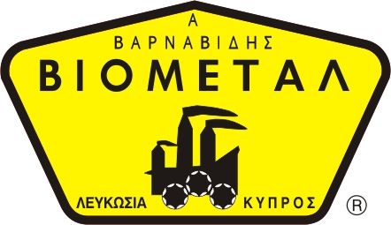
NICOSIA HEAD OFFICE
P.O.Box 21212, 1504 Nicosia. Cyprus
Tel: +357-22354744, Fax: +357-22354932
LIMASSOL OFFICE
Tel: +357-25589913, Fax: +357-25586407
e-mail: viometal@logosnet.cy.net
web: www.viometal.net
VIOMETAL LTD
A. V a r n a v i d e s
Manufacturing & Engineering

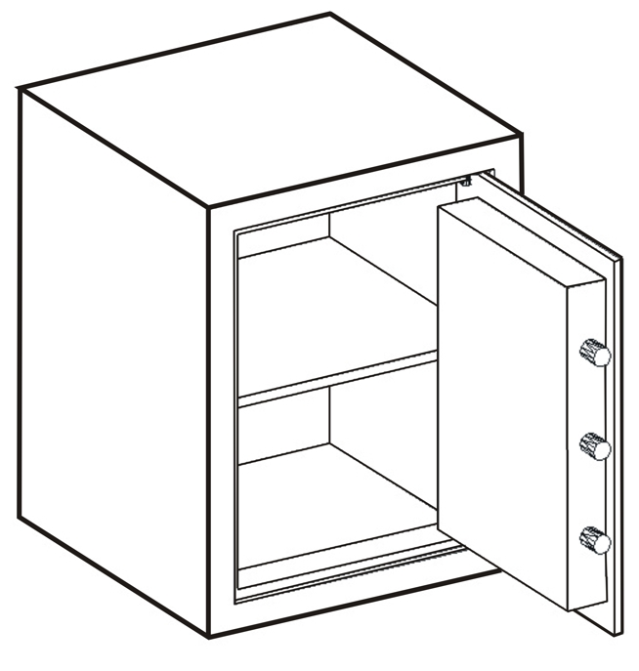
VIOMETAL VHS SERIES SAFES
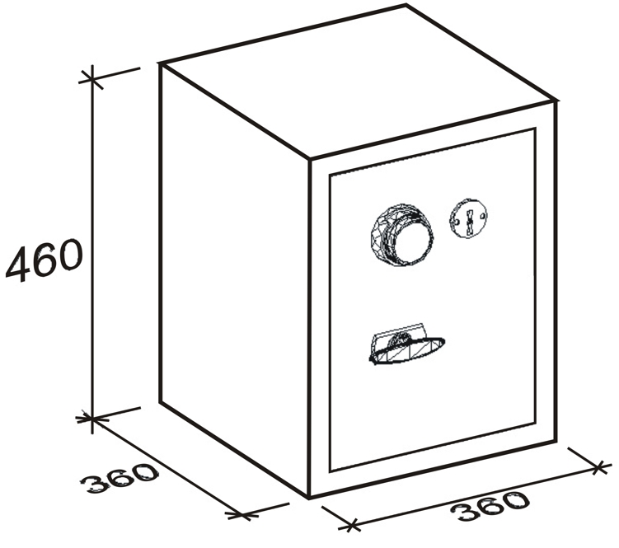
WITH COMBINATION AND/OR KEY-LOCK
FOR HOME AND OFFICE INSTALLATIONS
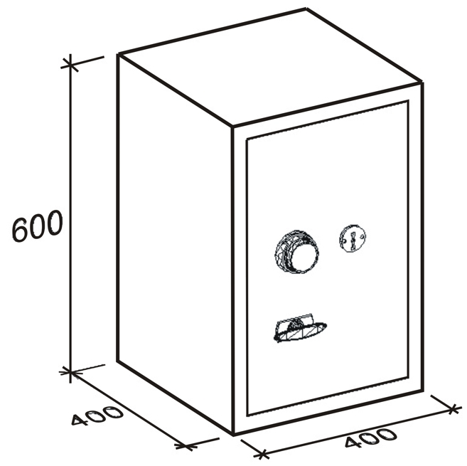

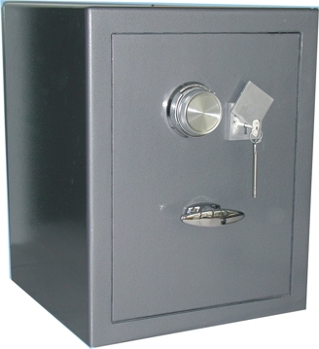
VHS46/KC
VHS60/KC

Code | External |  |  | Internal |  |  | Useful Volume | Weight | Price
Code | Width in mm | Depth in mm | Height in mm | Width in mm | Depth in mm | Height in mm | Useful Volume | Weight | Price
VHS46/KC | 360 | 360 | 460 | 330 | 270 | 440 | 35L | 50kg | €750.00+VAT (=€877.50)
VHS60/KC | 400 | 400 | 600 | 370 | 310 | 570 | 65L | 70kg | €850.00+VAT (=€994.50)

- Supplied by default with one key lock and one mechanical combination.
- Optional: Digital lock instead of mechanical €100.00+VAT (=€117.00).
  - Extra additional digital lock €280.00+VAT (=€327.60)

Ref: V002
SAFES 02,03
OFFICE FURNITURE, MOBILE SYSTEMS, STORAGE SYSTEMS, SHELVING SYSTEMS, SAFES & VAULTS

