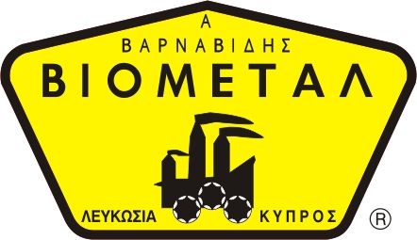
SAFES 01
NICOSIA HEAD OFFICE
P.O.Box 21212, 1504 Nicosia. Cyprus
Tel: +357-22354744, Fax: +357-22354932
LIMASSOL OFFICE
Tel: +357-25589913, Fax: +357-25586407
e-mail: viometal@logosnet.cy.net
web: www.viometal.net
VIOMETAL LTD
A. V a r n a v i d e s
Manufacturing & Engineering

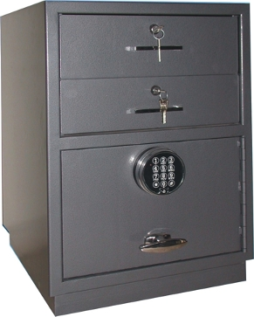
VIOMETAL CASH PROTECTOR UNIT

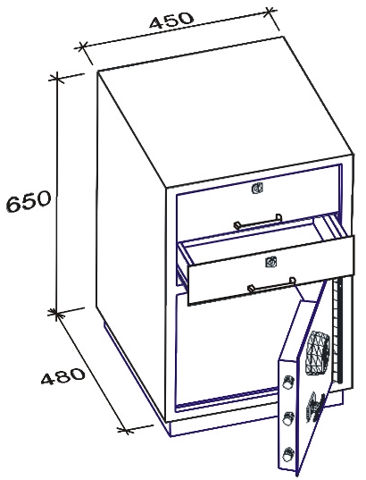
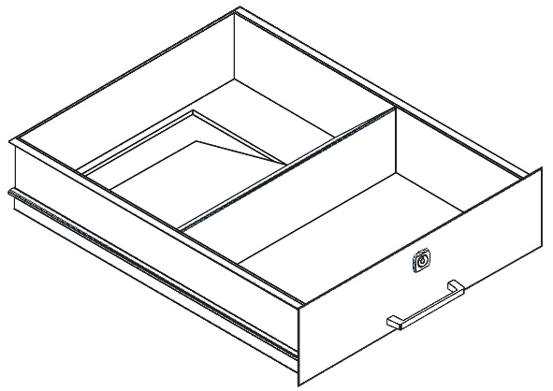

CPU 65
- Top drawer used for cash work.
- Second drawer used as cash drop.
- Bottom safe compartment protects excess cash with
time delay protection provided by Digital high security combination lock.
Dimensions: 45W x 50D x 65H
Weight: 65Kg
Price: €820.00 + VAT (=€959.40)

Ref: V001

OFFICE FURNITURE, MOBILE SYSTEMS, STORAGE SYSTEMS, SHELVING SYSTEMS, SAFES & VAULTS

